Software Testing Assignment

Module–1(Fundamental)

**1. What is SDLC?**

SDLC stands for Software Develop Life Cycle. It is a structured process used by software terms to plan, design, develop, test, deploy and maintain software systems.

**2. What is software testing?**

Software testing is a process used to identify the correctness, completeness and quality of developed computer software.

**3. What is agile methodology?**

Agile SDLC model is a combination of iterative and incremental process model with focuses on process adaptability and customer satisfaction by rapid delivery of working software product.

**4. What is SRS?**

A software requirements specification (SRS) is a complete description of the behaviour of the system to be developed.

**5. What is oops?**

Oops refers to Object Oriented programming system. Identifying objects and assigning responsibilities to these object. An object is like a Black box.

**6. Write basic concepts of oops**

Basic concept of oops:

* Class
* Object
* Encapsulation
* Inheritance
* Polymorphism
* Abstraction

**7. What is object?**

Object is an instances of a class.

Object = Data + Method

**8. What is class?**

Class is a collection of data member (variables) and member function (process, method) with its behaviour.

**9. What is Encapsulation?**

Encapsulation is wrapping up of data into single unit.

**10. What is Inheritance?**

Inheritance means properties of parent class extends into child class.

**11. What is polymorphism?**

Polymorphism means an ability to take one name having may forms or multiple forms.

**12. Draw Use case on online Light bill payment system (paytm/google pay).**

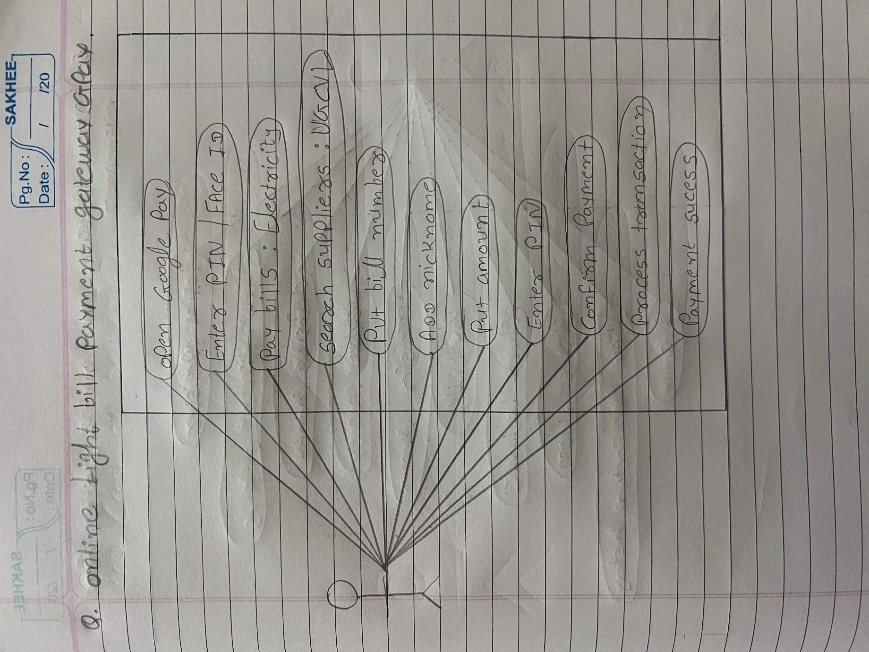

**13. Write SDLC Phases with basic introduction.**

SDLC phases:

* Requirement gathering
* Analysis
* Design
* Implementation
* Testing
* Maintenance

**Requirement gathering:** collect and understand the client’s needs. There are 2 types of requirement functional and non-functional.

Three types of problem can arise:

* Lack of clarity
* Requirement confusion
* Requirement amalgamation

**Analysis:** define project scope, resources, timeline and budget. Identify risks and create project plan.

**Design:** design architecture document. Convert requirement into a blue print. Create system architecture, database design, and UI/UX and dataflow diagrams.

**Implementation:** implementation code. Critical error removal. The implementation phase deals with issues of quality, performance and debugging.

**Testing:** quality is very important. Update all analysis, design and user documentation. Ensure bug-free and quality product delivering.

**Maintenance:** maintenance is a process of changing a system after it has been developed.

There are 3 types of maintenance:

* Corrective maintenance
* Adaptive maintenance
* Perfective maintenance

**14. Explain phases of the waterfall model.**

**1. Requirement collection:**

All system and software requirements are gathered from the client.

**2. Analysis:**

Define project scope, resources, timeline and budget. Identify risks and create project plan.

**3. Design:**

Convert requirement into a blue print. Create system architecture, database design, and UI/UX and dataflow diagrams.

**4. Implementation:**

Developers write the actual code based on the design documents. Implementation code. Critical error removal.

**5. Testing:**

Quality is very important. Update all analysis, design and user documentation. Ensure bug-free and quality product delivering.

**6. Maintenance:**

The software may require updates, bug fixes or enhancements. This phase ensures the system continues to function correctly over time.

**15. Write phases of spiral model.**

There are 4 phases in spiral model:

1. Planning

2. Risk analysis

3. Engineering

4. Customer evaluation

**16. Write agile manifesto principles**

There are principles of agile:

* Individual interaction
* Working software
* Customer collaboration
* Responding to change

**17. Explain working methodology of agile model and also write pros and cons.**

Agile SDLC model is a combination of iterative and incremental process model with focuses on process adaptability and customer satisfaction by rapid delivery of working software product.

**Pros:**

Suitable for fixed or changing requirements

Lower risks

Suitable for long project

It is very realistic approach to software development

**Cons:**

Depends heavily on customer interaction, if customer is not clear team can be driven in the wrong direction.

More risk of sustainability, maintainability and extensibility.

**18. Draw Use case on ATM Card transaction.**

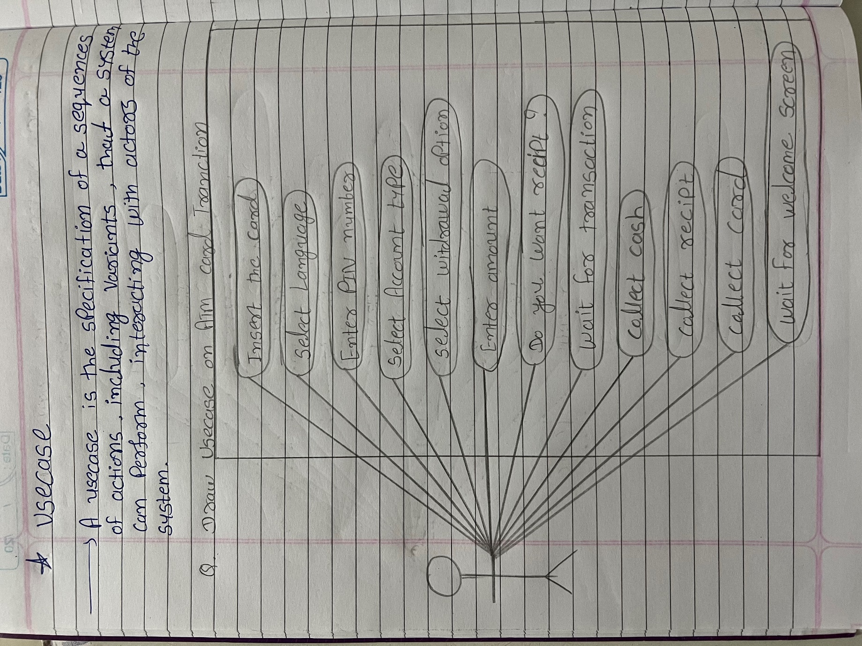

**19. Draw Use case on E-commerce application.**

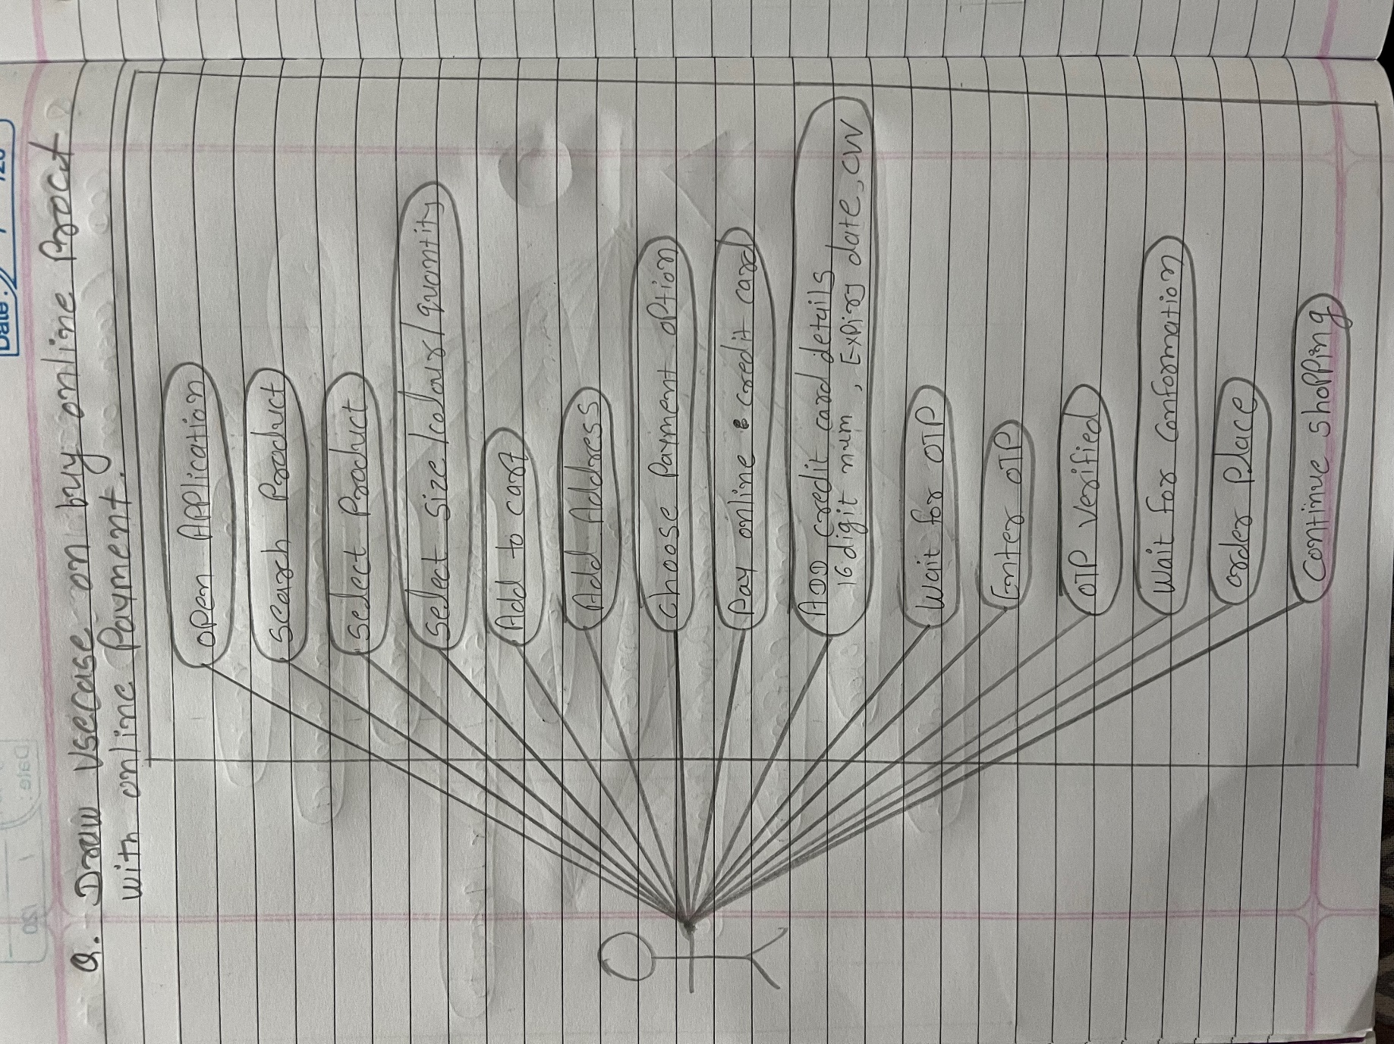

**20. Draw Use case on Online shopping product using payment gateway.**

